inglis street ELEMENTARY school

Upcoming Events: September
September 2- Organization Day (no classes)
September 3 – Professional Development Day (no classes)
September 3 – Ice Cream Social & Curriculum Night (6-7pm)
September 4 – First day for students
September 11 – Stand Up Against Bullying Day
September 11 – Wear Orange to recognize National Day for Truth and Reconciliation
September 24 – SAC (5pm)
September 29 – Professional Development Day (no classes)
September 30 – National Day for Truth and Reconciliation

Other Notable Dates:
- Treaty day is October 1

Principal: Gabe Rose Vice Principal: Ian MacRae

Admin. Assistant: Wendy Jegede
Phone: (902) 421-6767
Website: ise.hrce.ca Email: ises@hrce.ca
Safe Arrival: 1-833-582-6940
Reach the Inglis SAC at hrce-sac-ise@gnspes.ca

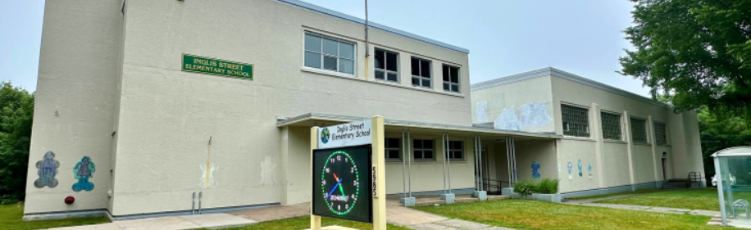

A Message from the Principal

September is here!

I hope you and your family are feeling ready for the new school year. September is always a busy but exciting time, and I’m looking forward to starting this next chapter together at Inglis.

My priority as we begin the year is to help students, families, and staff feel connected and supported. Over these first weeks, students and teachers will be busy building classroom communities and settling into learning routines - an important foundation for the year ahead.

I’ll be out front of the school each morning and look forward to meeting families there as we get started.

You’ll hear from your child’s teacher on September 3 by phone or email as we prepare for a strong start to the school year. Supply lists and important dates are available on our school website. Please review the information below to help your family get ready for the 2025–26 year at Inglis Street.

Here’s to a great September - let’s get started!

Gabe Rose
Principal

Bell Schedule

8:30 AM: Soft start, Students enter building and go to class
8:40 AM: Morning Announcements & Attendance
10:20 – 10:35 AM: Recess
11:50 – 12:45 AM: Lunch (all classes)
2:50 PM: Dismissal

Class Entry & Exit Locations

Lower Courtyard  (RED doors) | Main Office Door | Robie Street Doors | Inglis Street Doors
Pre-Primary 1  Pre-Primary 2  Primary MacKinnon | Primary Desrosier  2 Horsman  3/4 Haikings | 12Bowman/Stromberg  3Smallwood  5 MacRae/DeCruz  45MacIntyre | 4Farrell  P1Millett  56Mosher  12MacLeod  6Rideout

Supply Lists & Inglis Street School Calendar
Supply Lists for 2025-26 are posted on the ISE school website along with a new Inglis Street School Calendar.

Parking at Inglis Street
A Reminder to families that the Inglis Street School parking lot is for staff only between 8am and 4pm. Thank you for your help with this! We encourage active school travel at Inglis (walking, rolling, and biking to school).

YPHD Program
The YPHD Program is the only provider for before and after school programs at Inglis. To register for the YPHD Program, please click the link here or email childcare.registration@halifax.ymca.ca directly.

SchoolCash Setup
SchoolCash Online is an easy-to-use and safe way to pay for your children’s school fees. You can pay for your child’s yearbook, class trips and so much more, quickly and conveniently. Simply register an account to be able to pay in several different payment forms. Click here for more information.

Stand Up to Bullying Day is September 11
On the second Thursday of September, we recognize Stand Up Against Bullying Day.
On Thursday, September 11, we will celebrate inclusivity, kindness and friendship. All HRCE school teams are focused on ensuring all students have a safe and welcoming environment in which to learn and thrive.
Please join us and wear pink if you’re able on September 11 to take a stand against bullying.

School Technology
Inglis follows the NSEECD Cell Phone Directive for Nova Scotia released on June 6, 2024. Continuing with our school policy last year, all students are asked to:

- Refrain from bringing technology and smart devices to school
- All smart devices (watches, phones, etc.) are to stay in student backpacks and powered off during the school day (8:30 -2:50)

We encourage families to watch the video and read information on this directive here:
https://news.novascotia.ca/en/2024/06/06/new-cell-phone-directive-nova-scotia-schools#:~:text=Starting%20in%20the%202024%2D25,instructional%20purposes%2C%20will%20be%20available.

PowerSchool Opens for Families on September 3
PowerSchool will open to families on Wednesday, September 3 at 3 p.m. In PowerSchool, you’ll be able to view you child’s teacher(s) and/or class schedule.

Join us in observing National Day for Truth and Reconciliation
Each year on September 30, National Day for Truth and Reconciliation honours the children who didn't return from residential schools, as well as survivors, their families, and communities.
Orange Shirt Day, led by Indigenous communities, aims to raise awareness about the inter-generational impacts of residential schools and allows us all to show our support for the Every Child Matters movement.

As there are no classes on Monday, September 29 and Tuesday, September 30, we welcome staff and students to wear orange on Friday, September 26.

Demographic Form Update
On September 9, the Demographic Updates Form will be available to families in the PowerSchool Parent Portal. This form should be updated by every family to ensure all information about your child is current, including contacts, medical information, consents and demographics. Even if there are no anticipated changes, please still review this information and submit the form. This information will then be reviewed by the school before updates are finalized. This deadline to submit the form is October 6, 2025.

Student Belongings & Clothing
- Send all school supplies during the first week unless your child’s homeroom teacher advises otherwise.
- Students will store bags and coats in their cubbies daily.
- Provide a refillable water bottle — Inglis Street does not supply paper cups to reduce waste.
- Shoes or other footwear must be worn inside the building.
- A pair of indoor sneakers is required for classroom and gym use (outdoor shoes carry dirt and contaminants).
- Recess and lunch will be held outdoors in all weather — choose warm, weather-appropriate clothing your child can put on independently.
- Water-resistant mittens are recommended.
- Clearly label all clothing.
- Keep a change of clothes in a plastic bag inside your child’s backpack.

Lunch
Inglis is part of the Provincial School Lunch Program. Link here: https://nslunch.ca/ Wrappers will be sent home in lunch boxes. Inglis is a peanut aware zone. Please do not send students nuts or peanuts. Microwaves are not available.

HRCE Calendar
Please see the 2025-26 school calendar at the HRCE website here.

