inglis street ELEMENTARY school

Upcoming Events:

October
September 29 – Professional Learning Day (no classes)
September 30 – National Day for Truth & Reconciliation (no classes)
October 1 – Treaty Day
October 2 – School Photo Day
October 3 – School Photo Day (am only)
October 3 – Terry Fox Run (pm)
October 6 – 21 – Grade 6 Provincial Assessments
October 13 – Thanksgiving (no classes)
October 15 – SAC (5pm) & PTO (6pm)
October 20 – 24 School Bus Safety Week
October 23 – Halloween Haunt (6-7:30pm)
October 24 – NSTU Conference Day (no classes)
October 28 – Bus Evacuation Drills
Other Notable Dates:
- October is Mi’kmaq History Month

Principal: Gabe Rose Vice Principal: Ian MacRae

Admin. Assistant: Wendy Jegede
Phone: (902) 421-6767
Website: ise.hrce.ca Email: ises@hrce.ca
Safe Arrival: 1-833-582-6940
Reach the Inglis SAC at hrce-sac-ise@gnspes.ca

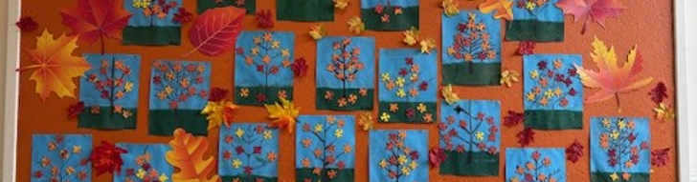

A Message from the Principal

Inglis Street Families,

September brought a lot of change at ISE. Thank you for your support and understanding as we shifted spaces and routines to accommodate a new homeroom. We are excited to welcome October and to begin settling into the routines and habits that will help us grow as learners here at ISE.

This month’s newsletter includes important information from our Parent-teacher Organization, ways we’re supporting Literacy at Inglis Street, Mi’kmaq History Month, School Bus Safety Week, and more!

Lastly, I want to recognize the hard work of our staff team in September. With shifting schedules and new spaces, they worked together to make sure students stayed supported and learning continued smoothly. I’m grateful for their dedication, and for the way our whole school community - families, staff, and students - pulled together during a month of change.

Wishing you a wonderful start to October!

Gabe Rose
Principal

School Access
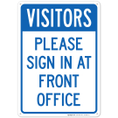
One of our safety protocols at Inglis Street is that all parents and visitors check in at the main office during school hours (8:30–3:10) and when meeting with a staff member after school.

If your child needs help getting to their classroom in the morning, a staff member will be happy to support them from the office. At dismissal, if your child is not in their designated area, please stop by the office first so we can assist you.

We also ask that all visitors and guests wear a volunteer ID tag while in the building. Thank you for helping us make Inglis Street a safe and welcoming place for every student.

Note from our Parent-Teacher Organization (PTO)
Just a quick note from your 2025-2026 PTO!
We had our first Parent Teacher Organization meeting this week to begin planning the extra events that happen outside of school time to just have fun and celebrate our wonderful school community.

Throughout the year, we will be asking for volunteers to help make the PTO events possible, and we are always happy to have more members on the PTO.

If you have any ideas for an event we could do or want to become a member of the PTO, please contact Miranda Chin at thechinfamily11@gmail.com

October 1 is Treaty Day
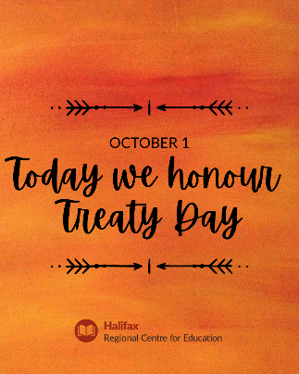

Celebrating and recognizing Treaty Day is an important way we can strengthen understanding and respect for Indigenous cultures and histories. It highlights the significance of treaties as living agreements that shape relationships between Indigenous peoples and the government. By educating students about Treaty Day, we promote awareness of Indigenous rights and contributions and encourage reconciliation. This celebration helps build a more inclusive and respectful society, where students learn the importance of honouring commitments and working together for a better future.

October 1 Mi’kmaq History Month

October is Mi'kmaq History Month, a time to celebrate and recognize the rich culture, history, and contributions of the Mi'kmaq people. In our schools, we can honour this month by incorporating Mi'kmaq stories, traditions and teachings into our curriculum. Activities such as guest speakers, art projects and cultural events can help students appreciate and understand the significance of Mi'kmaq heritage. Please join us in offering our respect, awareness and appreciation for the Mi'kmaq community and their enduring legacy. Learn more here.

October 20-24 is School Bus Safety Week
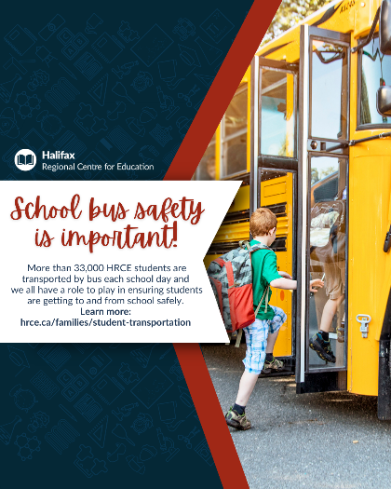
Student safety is a shared responsibility! During School Bus Safety Week, everyone can work together to ensure the safety of students on and around the school bus.
Did you know that HRCE has more than 33,000 students who ride the school bus every day? Here are some tips that everyone can follow to ensure all students get to school safely.
Bus Stop Safety
- Be on time for the bus and please don’t run to/from the bus.
- Stand back off the road and don't push or shove when waiting at a stop.
- Always cross in front of the bus. Walk three metres (10 feet) in front of the bus to a point where you can see the driver and wait for the driver's signal to cross. Proceed to the centre of the road, STOP, LOOK & LISTEN and cross the road when it is safe.
- Never crawl under a school bus or cross the road behind the bus.
- Know the danger zones around the bus.

School Bus Safety
- Please respect and listen to the driver and avoid distracting them.
- Please keep noise levels to a minimum.
- Do not stand or move seats while the bus is in motion.
- Never put your hands, arms, feet or head out of the bus window.
- Ask the driver for permission before you open the bus windows.
- Do not throw anything inside the bus or out of the windows.
- Keep the aisle clear at all times when the bus is in motion.

Literacy Screening
In September, classroom teachers spend time getting to know their students and who they are as learners. Schools will be using Universal Screening in Reading for Grade 1 and 2 students. This is one of the many ways teachers will assess learning.
What is Universal Screening in Reading?
It’s a short (1–5 minute) activity that helps us see how your child is developing key reading skills. Think of it as a quick check-in on their reading journey, like looking at a map to see where they are and what might help them move forward.

Why do we do it?
The screening helps teachers understand children's strengths and where they may need extra support. This allows us to plan instruction, so students get what they need to succeed in reading.

Important to know:
This is not a test. There’s no “pass” or “fail.” It's a way for teachers to ensure students are supported in their learning.

