inglis street ELEMENTARY school

Upcoming Events:

September
October is Mi’kmaq History month
October 1 - Picture Day
October 6 - Cross Country Meet (Gr. 3-6)
October 6 - Home & School Committee (6pm)
October 12 - Thanksgiving (no classes)
October 22 - School Assembly
October 19-23 Grade 6 Assessments
October 22 - Home & School Halloween Event (5-7pm)
October 23 - NSTU Provincial Conference Day (no classes)
October 19 - 23 School Bus Safety Week
Other Notable Dates:
- November 2 - Picture retake day
- November 10 - SAC (5pm) & Home & School (6pm)
- November 11 - Remembrance Day (no classes)
- November 20 - Assessment & Evaluation Day (no classes)
- November 30 - Reports released

Principal: Gabe Rose Vice Principal: Katherine Copeland

Admin. Assistant: Alex Chisholm
Phone: (902) 421-6767
Website: ise.hrce.ca Email: ises@hrce.ca
Safe Arrival: 1-833-582-6940
Reach the Inglis SAC at hrce-sac-ise@gnspes.ca

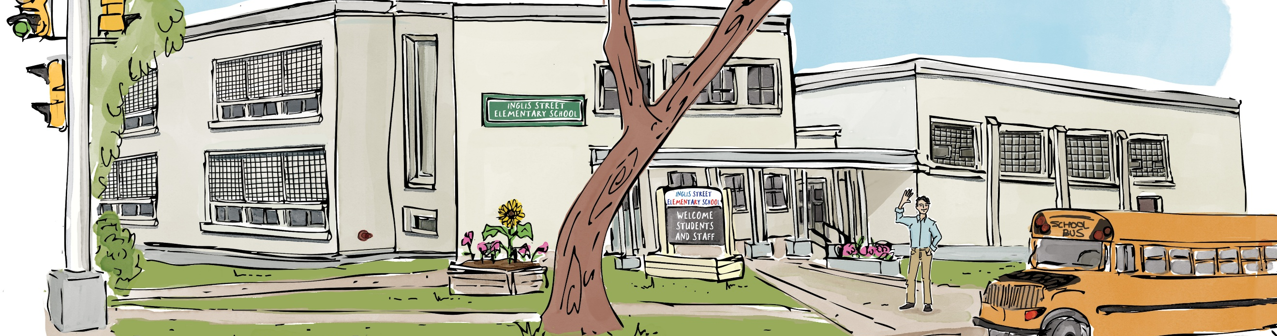

A Message from the Principal
September was a busy and exciting first month at Inglis Street!

Together, we settled into a new bell schedule and arrival routines, welcomed many new students, families, and staff, and had a great Curriculum Night. Thank you to our families for your support as we got the year underway.

We’re also excited to welcome our new Home & School Executive Committee, who will be leading lots of great community events this year. More information is included below!

As we settle into October, our staff are taking a close look at how our writers are doing and working as a team to set some goals for writing this year. Keep an eye on our newsletters for ways we can push our writers forward, together.

Making the most of our instructional time matters. A reminder to please have students at school before the 8:45 a.m. bell so they’re ready to start the day with their class and don’t miss important learning time.

October also marks Mi’kmaq History Month, an important opportunity for us to deepen our learning about Mi’kmaq history, culture, and contributions.

We’ve had a great start, and we’re excited for the month ahead!

Gabe Rose, Principal

Arrival Time
We know mornings can be busy, but a reminder that our entry bell rings at 8:45 a.m., with instruction beginning at 8:50 a.m. We’ve had a significant number of students arriving late, which can disrupt morning routines and means students are missing important instructional time.

Please help us by having your child at school no later than 8:45 a.m.

As a refresher, here is our Inglis Street bell schedule:

8:30–8:45 a.m.: Outdoor supervision
8:45 a.m.: Entry bell
8:50 a.m.: Instruction begins
10:30–10:45 a.m.: Recess (P–6)
10:45 a.m.: Entry bell
10:50 a.m.: Instruction begins
11:50 a.m.–12:50 p.m.: Lunch (P–6)
12:50 p.m.: Entry bell
2:50 p.m.: Dismissal

Home & School Committee: Halloween Event on October 22!
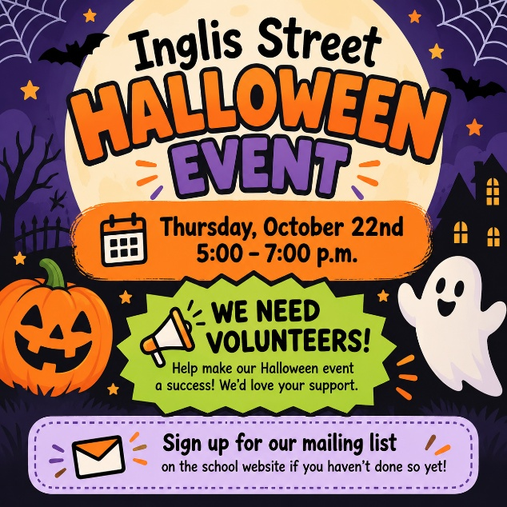
Our first Inglis Street Home & School community event of the year is coming up on Thursday, October 22nd from 5:00–7:00 p.m.!

Join us for an evening of Halloween fun while helping raise funds to support other events and activities at Inglis Street throughout the year. Our Home & School Committee will share more details with families as the date gets closer.

We need your help! These events come to life with the support of our school community. Please sign up to join our Home & School Volunteer Mailing List here if you haven’t already.

October 1 is Treaty Day

Treaty Day is an opportunity to learn, reflect and deepen our understanding of the historic and ongoing relationships between Mi’kmaq and non-Mi’kmaq people in Nova Scotia.

Treaties are not simply part of our past. They are living agreements that continue to shape our shared responsibilities today. In schools, Treaty Day provides an important opportunity to help students understand Mi’kmaq history, culture, rights and perspectives, while exploring what it means to live together in a spirit of respect, partnership and reciprocity.

By continuing to learn about the Treaties and our responsibilities within them, we help build stronger relationships and contribute to the ongoing work of reconciliation.

Check out the 2026-27 Inglis Street Parent Handbook
A reminder that our Parent Handbook for 2026–27 is available on our school website. It’s a helpful place to find all things Inglis Street, including important information, routines, procedures, and more.

Do you know how to raise a concern?
Did you know that there’s a protocol in place to help families contact schools or the HRCE office when you have concerns about your student’s education or well-being?

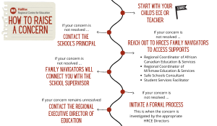
- All concerns should first be shared with your child’s teacher.
- If your concern is not resolved, you should then contact the principal.
- If your concern remains unresolved, you can reach out to HRCE’s Family Navigators who can provide information about a wide range of supports and resources.
- If your matter continues to be unresolved, you can then initiate a formal review process in which the matter will be investigated by the appropriate HRCE Directors.
- The final step is for your concern to be passed on to the Regional Executive Director.

Click here to learn more.

October 19-23 is School Bus Safety Week
Every school day, thousands of HRCE students rely on the bus to get to and from school safely.
School Bus Safety Week is a chance to highlight the simple habits that help keep everyone safe — from waiting well back from the road, to following the driver’s instructions, to staying alert around stopped school buses.
With more than 33,000 HRCE students travelling on more than 400 buses each day, safety depends on all of us: students, families, drivers, schools and motorists.
This week is a good opportunity to review a few everyday reminders and help reinforce safe routines on the bus, at the stop and on the road.
Bus Stop Safety
- Be on time for the bus and please don’t run to/from the bus.
- Stand back off the road and don't push or shove when waiting at a stop.
- Always cross in front of the bus. Walk three metres (10 feet) in front of the bus to a point where you can see the driver and wait for the driver's signal to cross. Proceed to the centre of the road, STOP, LOOK & LISTEN and cross the road when it is safe.
- Never crawl under a school bus or cross the road behind the bus.
- Know the danger zones around the bus.
School Bus Safety
- Please respect and listen to the driver and avoid distracting them.
- Please keep noise levels to a minimum.
- Do not stand or move seats while the bus is in motion.
- Never put your hands, arms, feet or head out of the bus window.
- Ask the driver for permission before you open the bus windows.
- Do not throw anything inside the bus or out of the windows.
- Keep the aisle clear at all times when the bus is in motion.
Remember: In Nova Scotia, it's illegal to pass a school bus when its red lights are flashing and the stop arm is extended.

You can find out more information about riding the school bus in HRCE here.

